|  |  |  |
| --- | --- | --- |
|  | **Name:**  **Year 12 Methods**  **Task 8: Test 5 –Continuous Random Variables and Normal Distribution** | Marks  _______  **50** |
|  | 7% of the year |
| Calc Free questions /20  Calc Assumed questions /30 | | |
| **Materials required:** Standard Writing Equipment Only  SCASA Formula Sheet  ***For Calculator Assumed***: CAS calculator (to be provided by the student)  A4 page of notes | | |

**CALCULATOR FREE SECTION**

**TIME: 20 minutes 21 MARKS**

1. **[3 marks]**

Determine the value(s) of *k* which make the following function a probability density function.



1. **[1, 2, 2, 1, 3 = 9 marks]**

The heights of fairy penguins in a particular geographic location are normally distributed with a mean height of 32 cm and a standard deviation of 1.5 cm.

Use the 68%, 95% and 99.7% rule to calculate each of the following.

a) Determine the probability that a randomly selected fairy penguin is taller than 30.5 cm.

b) Determine the probability of a randomly selected fairy penguin being shorter than 30.5 cm if it is known that they are in the 0.5 quantile.

c) In a sample of 2000 penguins, how many would you expect to be taller than 35cm?

d) What is the maximum height of the shortest 2.5% of penguins in this location?

e) In a different geographic location the mean height of the fairy penguins found there is 33 cm. If 97.5% of the penguins are shorter than 38cm, and their heights are also normally distributed, what is the standard deviation for this population?

**3.** **(5 marks:2,1,2)**

The continuous variable X has probability density function:

f(x) = $\left\{\begin{aligned}3x^{k } 0≤x≤1 \\ 0 otherwise \end{aligned}\right.$ where k is a positive integer

Find (a) the value of k

(b) the mean of X

(c) the value of a, such that P( X $≤$ a) = 0.008

1. **[3 marks]**

On a recent test, Tom scored 70% and his standard score was 1. Jerry sat the same test and his standard score was -0.5 when he scored 55%.

Calculate the mean and standard deviation for these test results.

END OF CALCULATOR FREE SECTION

**YEAR 12 METHODS**

**Test 5 –Continuous Random Variables and Normal Distribution**

**NAME:**

**CALCULATOR ASSUMED SECTION**

**TIME: 30 minutes 30 MARKS**

______________________________________________________________________________

**5. [1, 2 = 3 marks]**

Consider the probability density function of the random variable Y drawn below,  .

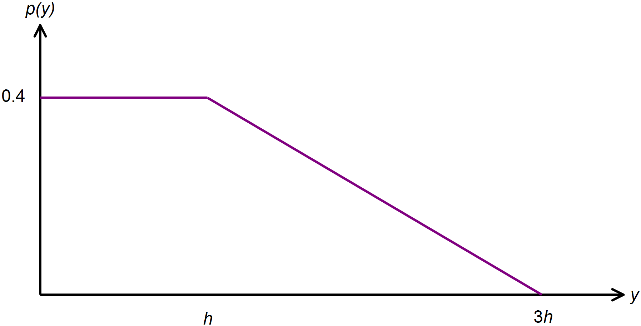 a) Calculate the value of *h.*

b) Calculate *k* such that 

**6. [1, 1, 1, 2, 2, 1, 1, 2 =11 marks]** During December, a local shopping centre has a gift wrapping stall which is open 12 hours a day. On average, the gift wrapping stall serves 120 customers per day.

a) What is the average length of time between serving each customer at this gift wrapping stall? Give your answer in minutes.

This scenario can be best modelled by an exponential probability density function which is given by  where  is the mean time between serving customers.

b) Hence state the probability density function for X, where X represents the time between serving each customer.

c) Show, using calculus methods, that your answer to part (b) does in fact represent a continuous probability density function.

d) Show, using calculus methods, that the standard deviation of the distribution is the same as the mean.

e) If the time between serving customers was instead recorded in hours, determine the new mean and variance of the distribution.

f) Calculate the median waiting time, in minutes, between customers.

Calculate the probability that the next customer will be served:

g) less than 5 minutes after the previous one.

h) less than 8 minutes after the previous one given that it took longer than 5 minutes.

**7. [3, 1, 1, 2, 2 =9 marks]** A new battery in an electric car has a charge that can last on average for 150km of travel with a standard deviation of 21km. Testing is underway to evaluate the performance of these batteries. Assume their range of distance to be normally distribution.

a) Determine the probability that a randomly selected battery:

(i) Can be used for at least 140km before it needs to be charged.

(ii) Can be used for more than 165km if it is known that it can be used for  
 at most 180km.

b) The worst performing 3% of batteries will be studied for their deficiencies. What is the maximum distance one of these batteries can be used for?

c) In a sample of 250 batteries, how many would you expect to be in the 0.85 quantile?

d) A car dealer has three electric cars with this new battery.

(i) What is the probability that the first two cars have a battery that will last greater than 170km and the third less than 170km?

e) To improve the consistency of the battery performance, a team of engineers decide that at most 0.27% of batteries should last less than 100km. Calculate the value of the new standard deviation for this normal distribution if the mean remains the same.

**8. [2 marks]**

The amount of milk sold in 2L containers is normally distributed with a mean of 1998 mL.

Out of 1000 bottles tested, 248 contained between 1998 mL and 2001 mL.

Calculate the standard deviation of the amount of milk contained in these 2L containers.

**9. [5 marks]**

The probability density function of a continuous random variable X is given by:



Calculate the value of *P* and *Q* if the mean of the distribution is  .

END OF CALCULATOR ASSUMED SECTION